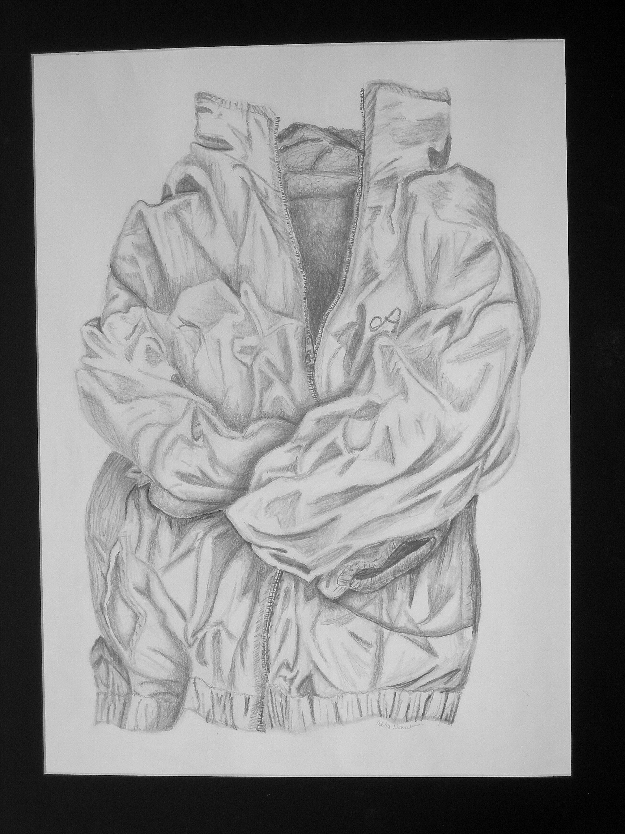 Who I Am is What I Wear…

- Read Article What is Fashion?
- Discuss article.
- Individually – think about childhood…what fashions describe your childhood?
- As class, discuss brainstorms about childhood fashions in class.
- Homework – choose at least 3 articles of clothing, do a thumbnail sketch of each in sketchbook. Draw object in such a way that it will illustrate your personality. Students can enhance/redesign clothes in any way to further illustrate your personality.
- Emphasize creating attitude or how you feel that you are perceived by others through point of view, balance, value and emphasis.
- Think about line and negative space. Use expressive line that will further emphasize your personality. Also, look at the negative space that your object creates within the composition of the paper. How does it help? How does it hinder?

Artist Statement

In order to write your artist statement, you will need to follow these guidelines.
1st paragraph
What is the title of your artwork?
Where are you now and where do you want to be in the future?
What article of clothing did you choose for the project?

2nd paragraph
How did you draw your article of clothing to illustrate your personality?
If you redesigned or enhanced your article of clothing how did this further illustrate your personality?
How did you create an attitude through point of view, balance, value and emphasis?

3rd paragraph
This paragraph should be a summary and should include what you may have learned about yourself through this artwork.

Haiku
Write a haiku as an evaluation of self today and into the future.
1st line 5 syllables / concrete reference to the article of clothing
2nd line 7 syllables / begin with an action word that transitions into something about your personality
3rd line 5 syllables / focus on a concept of self/goals/dreams

Who I Am is What I Wear…
Name___________________________________________
Criteria | Possible Points | Points Given
Point of View | 35
Balance | 35
Emphasis | 35
Value | 50
Craftsmanship | 25
Creativity | 50
Total Points Possible | 230

Artist Statement
Criteria | Possible Points | Points Given
3 Paragraphs | 10
Answered All Questions | 30
Craftsmanship | 20
Descriptive | 20
Total Points Possible | 80

Haiku
Criteria | Possible Points | Points Given
Followed Criteria | 10
Craftsmanship | 10
Creativity | 10
Total Points Possible | 30

